**General:**

* Click 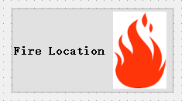 button to get the fire location shown on the map.
* 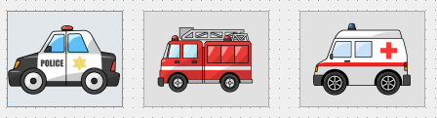 Choose which service you need.

**Data:**

* Open scenario: Open the scenario file.
* Save scenario: Save the file.
* 



Select the attributes you need in the layer.

**Analysis:**

*  Click the button to get all the possible roads between the fire station and fire location.
* Click to add obstacles.
* Get the shortest roads and avoid the obstacles and show it in new layer.
* Clean roads.
* 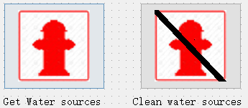Get/clean water sources (hydrants and rivers) inside a buffer of the fire location.
* 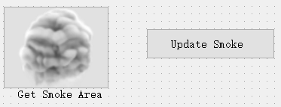get the real-time area threatened by smoke and update it.
* 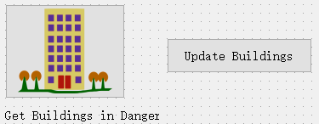Get the buildings threatened by the smoke highlighted and shown in a new layer.

**Analysis**

* Charts to show the population which needs to be evacuated.
* Charts to show the calculated number of different building types in danger.
* The fire duration.